EC-467 Mobile Application Development

BS (CE)-2021 LAB REPORT #6
Submitted By:

Reg. No. | Name
21-CE-009 | Huzaifa Shahbaz

Department of Computer Engineering
HITEC University Taxila
 | Presentation  (Format(0.5)+  Title (0.5)+  Conclusion(1)  +Procedure(2)  +Objective(1)) | Calculation/ Coding | Observation/  Program Results | Total
Total | 5 | 5 | 5 | 15
Obtained

Lab Instructor.
Dr. Muhammad Bilal

LAB REPORT #6
List View and Base Adapter
Introduction: Android List View is a view which groups several items and display them in vertical scrollable list. The list items are automatically inserted to the list using an Adapter that pulls content from a source such as an array or database. Android provides several subclasses of Adapter that are useful for retrieving different kinds of data and building views for an Adapter View (i.e. List View or Grid View). The common adapters are • Array Adapter • Base Adapter
Base Adapter is a common base class of a general implementation of an Adapter that can be used in List View, Grid View, Spinner etc. Whenever you need a customized list in a List View or customized grids in a Grid View you create your own adapter and extend base adapter in that. Base Adapter can be extended to create a custom Adapter for displaying a custom list item.
Objectives of the experiment: • To get basic understanding List View and Base Adapter • To be able to use List View and Base Adapter in android applications. • To get to know about the benefits related to List View.
Software used: Android Studio Iguana
Class Task:
XML CODE OF MAIN ACTIVITY:
<?xml version="1.0" encoding="utf-8"?>
<LinearLayout xmlns:android="http://schemas.android.com/apk/res/android"
xmlns:app="http://schemas.android.com/apk/res-auto"
xmlns:tools="http://schemas.android.com/tools"
android:layout_width="match_parent"
android:layout_height="match_parent"
android:fitsSystemWindows="true"
android:orientation="vertical"
tools:context="OperatingSystemCustomAdapter.OperatingSystemActivity">
<TextView
android:layout_width="match_parent"
android:layout_height="wrap_content"
android:textSize="32sp"
android:text="Operation Systems">
</TextView>
<ListView
android:id="@+id/os_list_view"
android:layout_width="match_parent"
android:layout_height="match_parent"/>
</LinearLayout>
XML CODE OF ACTIVITY OF OPERATING SYSTEM:
<?xml version="1.0" encoding="utf-8"?>
<LinearLayout xmlns:android="http://schemas.android.com/apk/res/android"
xmlns:app="http://schemas.android.com/apk/res-auto"
xmlns:tools="http://schemas.android.com/tools"
android:layout_width="match_parent"
android:layout_height="wrap_content"
android:orientation="horizontal">
<ImageView
android:id="@+id/os_image_view"
android:layout_width="wrap_content"
android:layout_height="wrap_content"
<TextView
android:id="@+id/os_name_text_view"
android:layout_gravity="center"
android:layout_width="wrap_content"
android:layout_height="wrap_content"
android:text="TextView">
</TextView>
</LinearLayout>

JAVA CODE OF MAIN ACTIVITY:
package com.huzaifashahbaz.madlab6;
import android.os.Bundle;
import android.widget.ListView;
import androidx.appcompat.app.AppCompatActivity;
import java.util.ArrayList;
public class MainActivity2 extends AppCompatActivity {
@Override
protected void onCreate(Bundle savedInstanceState) {
super.onCreate(savedInstanceState);
setContentView(R.layout.activity_main2);
ArrayList<String> osAL = new ArrayList<String>();
osAL.add("Android");
osAL.add("iOS");
osAL.add("Windows");
ArrayList<Integer> osIconAL = new ArrayList<Integer>();
osIconAL.add(R.mipmap.os_w);
osIconAL.add(R.mipmap.os_ios);
osIconAL.add(R.mipmap.os_windows);
OperatingSystemCustomAdapter adapter = new OperatingSystemCustomAdapter(this, osAL, osIconAL);
ListView listView = findViewById(R.id.os_list_view);
listView.setAdapter(adapter);
}
}
JAVA CODE OF BASE ADAPTER:
package com.huzaifashahbaz.madlab6;
import android.content.Context;
import android.view.LayoutInflater;
import android.view.View;
import android.view.ViewGroup;
import android.widget.BaseAdapter;
import android.widget.ImageView;
import android.widget.TextView;
import java.util.ArrayList;
public class OperatingSystemCustomAdapter extends BaseAdapter {
private Context context;
private ArrayList<OperatingSystem> operatingSystems;
public OperatingSystemCustomAdapter(Context context, ArrayList<OperatingSystem> operatingSystems) {
this.context = context;
this.operatingSystems = operatingSystems;
}
@Override
public int getCount() {
return operatingSystems.size();
}
@Override
public Object getItem(int position) {
return operatingSystems.get(position);
}
@Override
public long getItemId(int position) {
return position;
}
@Override
public View getView(int position, View convertView, ViewGroup parent) {
if (convertView == null) {
convertView = LayoutInflater.from(context).inflate(R.layout.list_item_operating_system, parent, false);
}
OperatingSystem os = (OperatingSystem) getItem(position);
TextView nameTextView = convertView.findViewById(R.id.os_name_text_view);
ImageView iconImageView = convertView.findViewById(R.id.os_icon_image_view);
nameTextView.setText(os.getName());
iconImageView.setImageResource(os.getIconResourceId());
return convertView;
}
}
Result:
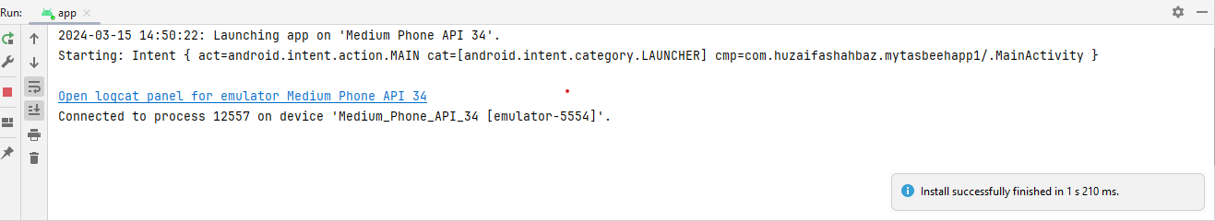
OUTPUT:
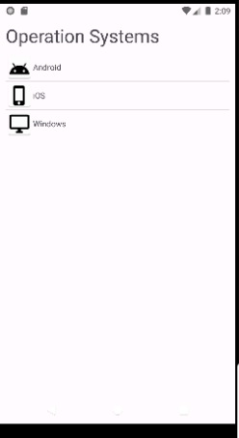
HOME TASK:
Design a list view to show country flag, name, and their capital city as shown in the figure below. Add at least three countries into the list.
XML CODE OF MAIN ACTIVITY:
<?xml version="1.0" encoding="utf-8"?>
<LinearLayout xmlns:android="http://schemas.android.com/apk/res/android"
xmlns:app="http://schemas.android.com/apk/res-auto"
xmlns:tools="http://schemas.android.com/tools"
android:layout_width="match_parent"
android:layout_height="match_parent"
android:fitsSystemWindows="true"
android:orientation="vertical"
android:padding="1mm"
tools:context=".MainActivity">
<TextView
android:layout_width="match_parent"
android:layout_height="wrap_content"
android:textSize="32sp"
android:layout_marginBottom="1mm"
android:text="Countries List">
</TextView>
<ListView
android:id="@+id/os_list_view"
android:Layout_width="match_parent"
android:layout_height="match_parent">
</ListView>
</LinearLayout>
XML CODE OF COUNTRY_ITEM ACTIVITY:
<?xml version="1.0" encoding="utf-8"?>
<LinearLayout xmlns:android="http://schemas.android.com/apk/res/android"
xmlns:app="http://schemas.android.com/apk/res-auto"
xmlns:tools="http://schemas.android.com/tools">
<Linearlayout>
<TextView
android:id="@+id/os_name_text_view"
android:layout_width="wrap_content"
android:layout_height="wrap_content"
android:text="TextView"
android:textSize="25sp" />
<TextView android:id="@+id/subtext">
</TextView>
</Linearlayout>
<EditText
android:id="@+id/editTextText"
android:layout_width="wrap_content"
android:layout_height="wrap_content"
android:layout_weight="1"
android:ems="10"
android:inputType="text"
android:text="Name" />
</LinearLayout>

JAVA CODE OF MAIN ACTIVITY:
package com.huzaifashahbaz.madlab6;
import android.os.Bundle;
import android.widget.ListView;
import androidx.appcompat.app.AppCompatActivity;
import java.util.ArrayList;
public class MainActivity2 extends AppCompatActivity {
@Override
protected void onCreate(Bundle savedInstanceState) {
super.onCreate( savedInstanceState );
setContentView( R.layout.activity_main2 );
ArrayList<String> osAL = new ArrayList<>();
osAL.add( "Pakistan" );
osAL.add( "China" );
osAL.add( "England" );
ArrayList<String> subtext = new ArrayList<>();
subtext.add( "Islamabad" );
subtext.add( "Beijing" );
subtext.add( "London" );
ArrayList<Integer> osIconAL = new ArrayList<>();
osIconAL.add( R.mipmap.Pakistan );
osIconAL.add( R.mipmap.China );
osIconAL.add( R.mipmap.England );
OSAdapter adapter = new OSAdapter( this, osAL, subtext, osIconAL );
listView listView = findViewById( R.id.os_list_view );
listView.setAdapter( adapter );
}
}

JAVA CODE OF CUSTOM ADAPTER:
package com.huzaifashahbaz.madlab6;
import android.os.Bundle;
import android.widget.ListView;
import androidx.appcompat.app.AppCompatActivity;
import java.util.ArrayList;
public class OperatingSystemCustomAdapter extends BaseAdapter {
ArrayList<String> osAL;
ArrayList<Integer> osIocnAL;
LayoutInflater inflater;
public OperatingSystemCustomAdapter(Context context, ArrayList<String> osAL, ArrayList<Integer> osIocnAL) {
this.osAL = osAL;
this.osIocnAL = osIocnAL;
inflater = LayoutInflater.from(context);
}
@Override
public int getCount() {
return osAL.size();
}
@Override
public Object getItem(int position) {
return null;
}
@Override
public long getItemId(int position) {
return 0;
}
@Override
public View getView(int position, View convertView, ViewGroup parent) {
convertView = inflater.inflate(R.layout.os_item_layout, null);
ImageView countryFlagImageView =
convertView.findViewById(R.id.os_image_view);
TextView countryTV = convertView.findViewById(R.id.os_name_text_view);
countryFlagImageView.setImageResource(osIocnAL.get(position));
countryTV.setText(osAL.get(position));
return convertView;
}
}

Result:
OUTPUT:
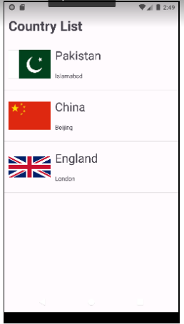
Conclusion:
In conclusion, we had known the techniques of List View and base Adapter in Android Studio. We also me the two apps country list and operating system by using List View and base Adapter also we see their function and working in android studio.

